

Managing Projects Table

User Guide

Prepared by The Woodland Rangers

UGA MBT Capstone Project

April 28, 2018

The purpose of this document is to give administrator guidance on managing the Projects Table using the phpMyAdmin interface available on the 1and1.com site. For detailed information on how to use phpMyAdmin, please refer to the phpMyAdmin User Guide.

The database for the volunteer and friends information that is accessible by the Volunteer Application and Admin Tool Box is called FSGWData. To access the database, log in to the 1and1.com Control Panel. On the left-side menu bar of the control panel, click on “MySQL Database.”

Next, click on the “Open” link for FSGWData (db358933030) under the phpMyAdmin column to access the database administration utilities.

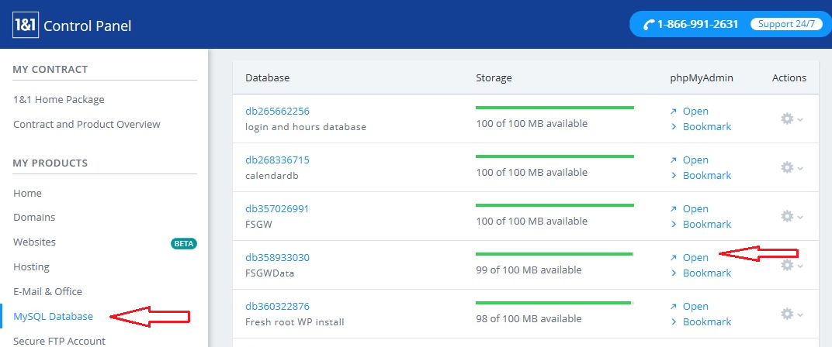

**Projects Table**

The Projects table contains a listing of projects as defined by FSGW. Inside phpMyAdmin, you will see the information about the configuration of the database and a listing of the database tables. By clicking on the Projects table, you can access it to edit existing project name and add more project names to this table. *NOTE: Deleting an existing project record from this table is NOT recommended because it may have been used in previous records.*

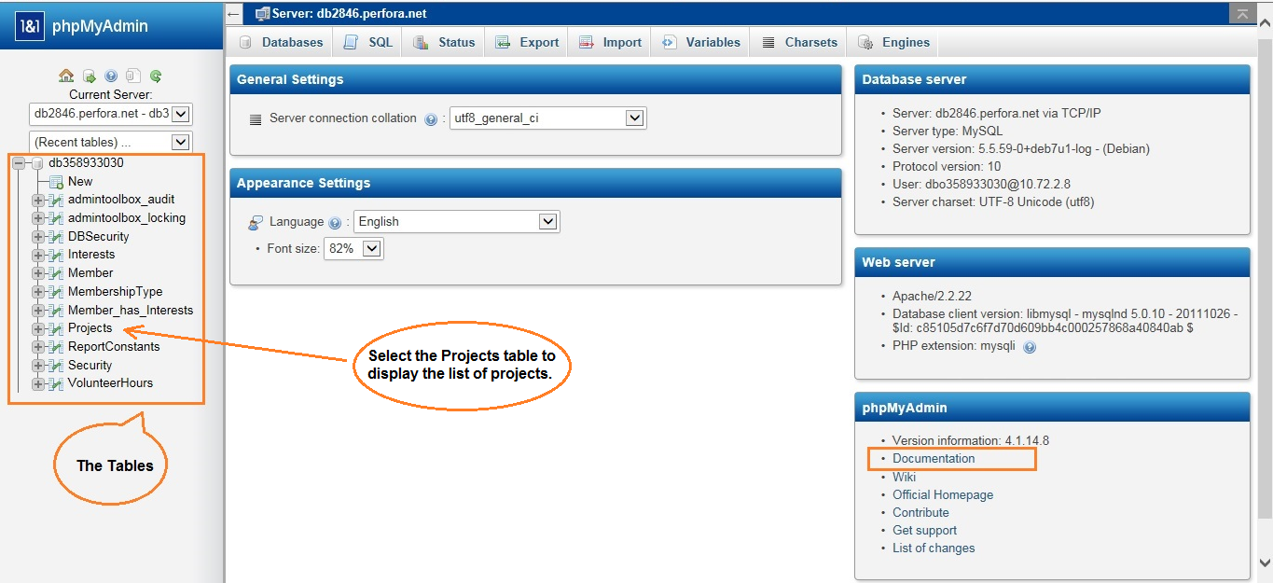

**Editing an Existing Project Record**

When you click on the Projects table, a listing of the table elements is provided on the right window with various tabs. In the “Browse” tab, you can edit any existing projects by checking the box on the left of a project record that needs to be updated. Then, you can click on either one of the Edit links (with a pencil icon) to update the selected record.

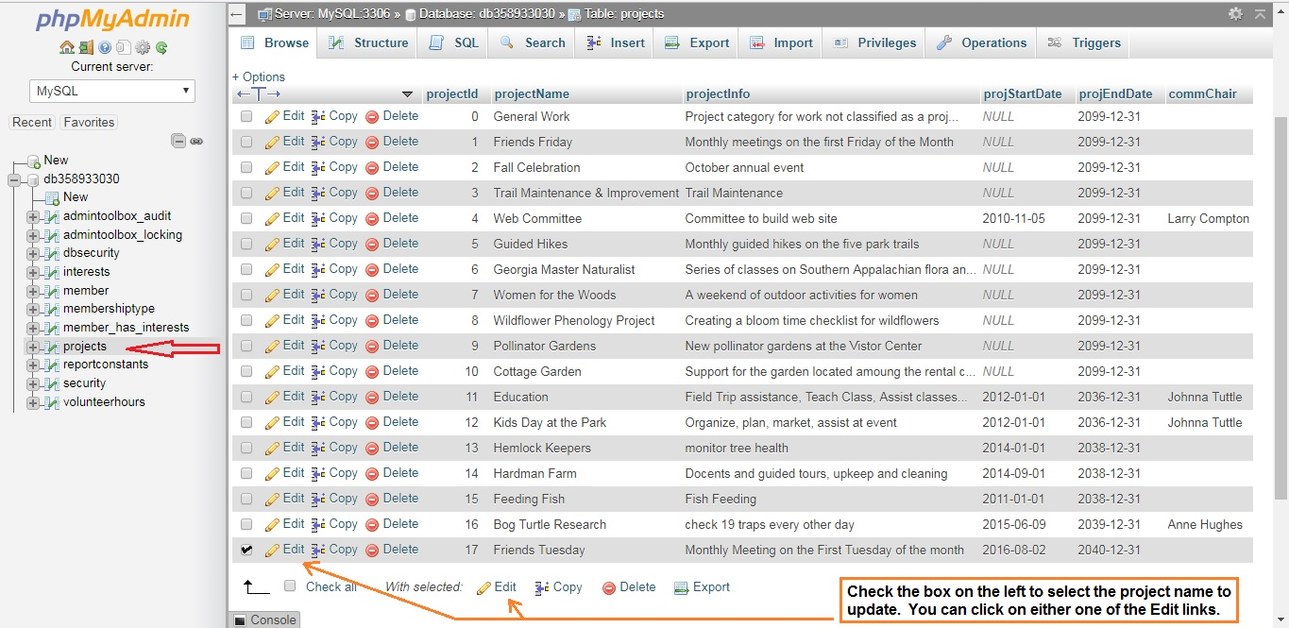

When the Edit link is clicked, a screen with the field contents for that record is displayed. You can change the project information EXCEPT for the “projectId”. When all changes are complete, click on “Go” to save your changes.

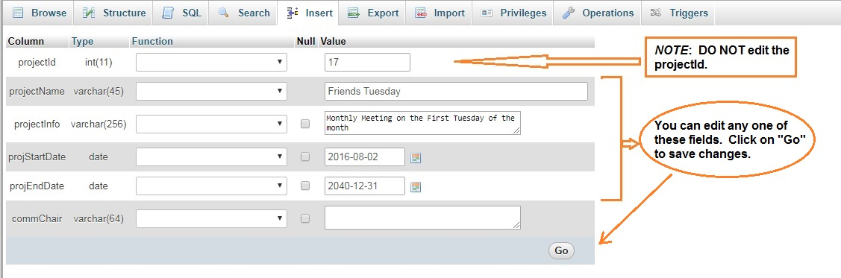

**Inserting a New Project**

The Insert tab provides an easy to use menu to add a new project record to the table. The fields that are required are noted by not having the Null column checked. Fields that have predefined defaults are already filled in. See an example below.

